**DAILY ONLINE ACTIVITIES SUMMARY**

|  |  |  |  |  |  |  |  |  |
| --- | --- | --- | --- | --- | --- | --- | --- | --- |
| **Date:** | **22/07/2020** | | | | | **Name:** | **PRANEETA P HANDRAL** | |
| **Sem & Sec** | **4​th​ SEM. & ‘B’ SEC.** | | | | | **USN:** | **4AL19CS401** | |
| **Online Test Summary** | | | | | | | | |
| **Subject** | | **_ _ _ _ _** | | | | | | |
| **Max. Marks** | | **30** | | **Score** | | | **_ _** | |
| **Certification Course Summary** | | | | | | | | |
| **Course** | **SQL for Data Science** | | | | | | | |
| **Certificate Provider** | | | **Coursera** | | **Duration** | | | **14 Hrs.** |
| **Coding Challenges** | | | | | | | | |
| **Problem Statement:** _ _ _ _ _ _ _ _ | | | | | | | | |
| **Status: _ _ _ _ _** | | | | | | | | |
| **Uploaded the report in Github** | | | | | **Yes** | | | |
| **If yes Repository name** | | | | | **LockdownCoding**  <https://github.com/praneetahandral/lockdowncoding> | | | |
| **Uploaded the report in slack** | | | | | **Yes** | | | |

**Online Test Summary: No internal conducted today.**

**Online Certification course Summary** Today I have learn about **Data Models, Data Models, Part 3: Relational vs. Transactional Models.**

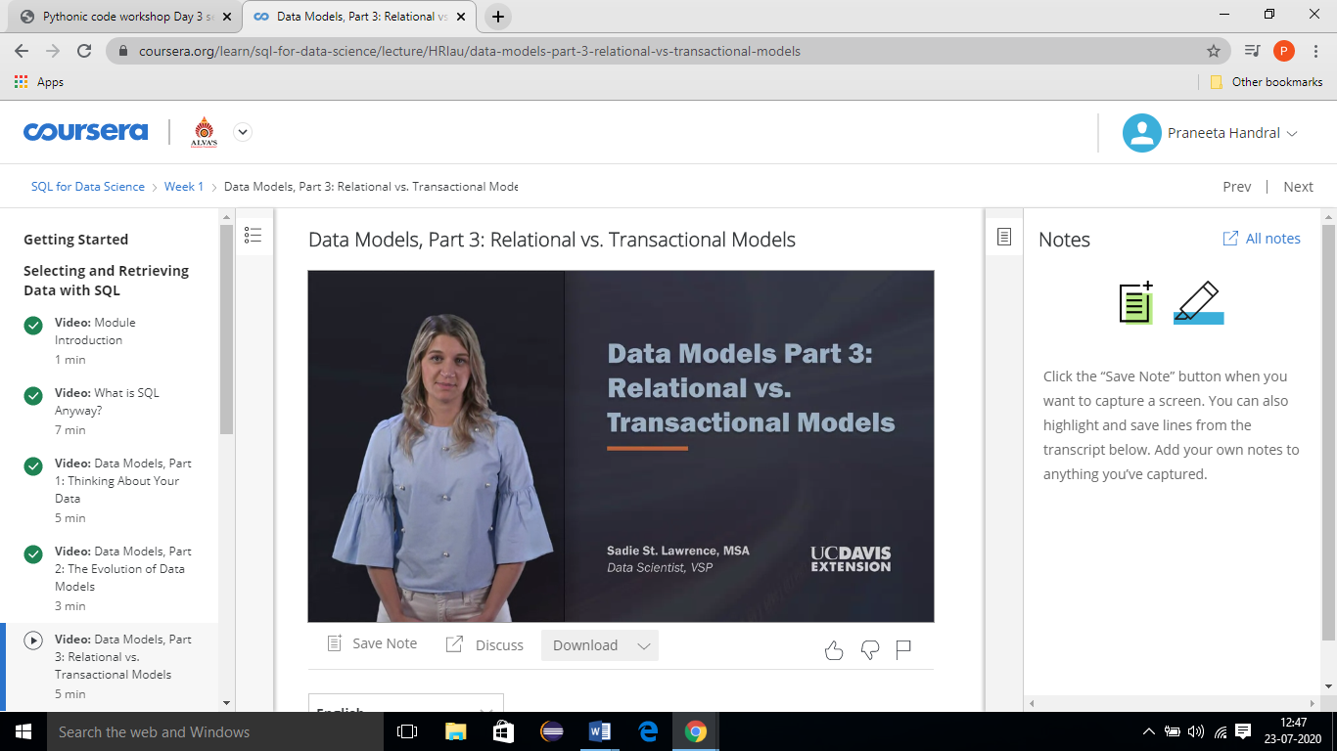

**Online Coding Summary​:- Today I didn’t receive the program.**

**Online Training Program:-**Day 1 online workshop on How to develop Pythonic coding rather than Python coding- Logic Perspective organized by prof.Dr.S.Mohideen Badhusha, Department CSE,AIET,Mijar

